Chapter 4 – Modelling Lubricated Bearings in a Flexible Multi-Body Dynamic Environment

# Preface

Modelling powertrain systems in flexible multi-body (FMB) environments can enable substantial cost and time savings for automotive manufacturers due to a reduced need for physical prototyping. With increasing complexity and operational speeds of these systems, the accuracy at component level is paramount. Bearings are a crucial component of powertrain architectures and their dynamic response significantly affects the behaviour of the interconnected systems.

Modern electrified powertrains operate at significantly higher speeds and lower loads than conventional powertrains. This leads to much higher lubricant entrainment velocities at the roller-race conjunction of the bearings. Consequently, the film thickness can be of the same order of magnitude and often exceed that of the contact deformation predicted by dry Hertzian assumptions; hence, dry analyses are no longer valid. Neglecting this film leads to an underestimation of the deflection at the roller-race contact and hence the reaction load, affecting the dynamic response of the bearing and system.

This work uses an explicitly coupled simulation approach for tribodynamic analysis of a high-speed shaft bearing system. A flexible shaft is supported by two cylindrical roller bearings in a commercially available flexible multi-body software. The kinematic behaviour of the bearing races at each step of the dynamic analysis is passed to a separate lubricated component level bearing model during the simulation. A contact slicing method is employed to calculate the reaction forces of the individual rolling elements based on the contact deflection, with implicit inclusion of the elastohydrodynamic (EHL) lubricant film. Resultant forces on the races are returned to the system level model and the equations of motion are solved. High-speed tribodynamic analysis using lubricated bearings in a flexible system level model has not, to the author’s knowledge, been reported in open literature.

Time -domain results have been analysed to compare dry and lubricated modelling methods. For lightly loaded cases at 12 000 rpm, the film reaches a thickness of 4.3 µm. Contact forces in the bearings under these conditions are up to 16 times greater in the lubricated model compared to the dry assumption. This highlights the necessity of this multi-physics tribodynamic approach for future high-speed powertrain system modelling.

# Table of Contents

1 Preface 1

Table of Contents 2

List of Figures 3

List of Tables 4

2 Introduction 5

3 Methodology 6

3.1 System Level Flexible Multi-Body Dynamic Model 6

3.1.1 Governing Equations 8

3.2 Co-Simulation of Coupled Models 10

3.2.1 Link to MATLAB 11

3.3 Lubricated Component Level Bearing Model 14

3.3.1 Force-Deflection Relationship 14

3.3.2 Damping 17

3.3.3 Implicit Tribological Model 18

4 Results 20

4.1 Dry vs Lubricated Roller Contact Conditions 20

4.2 Dry vs Lubricated Speed Sweep Operating Envelopes 24

4.2.1 Inner Race Displacement – Z-Direction 25

4.2.2 Inner Race Force – Z-Direction 25

4.2.3 Contact Deformation 26

4.2.4 Contact Force 27

4.2.5 Contact Stiffness 27

4.2.6 Total Bearing Stiffness 28

4.3 Greenwood Regimes of Lubrication 28

5 Conclusion 30

6 Additional Work for Chapter 31

7 Nomenclature 32

# List of Figures

Figure 1 - Flowchart of models 6

Figure 2 - 2D representation of flexible shaft model 7

Figure 3 - Connection pins and degrees of freedom 11

Figure 4 - Output port Demux blocks and degrees of freedom 12

Figure 5 - Input port Mux blocks and degrees of freedom 12

Figure 6 - Simulink model layout 13

Figure 7 - Bearing schematic 14

Figure 8 - Validation of slicing technique used in the model against experimental data by de Mul et. al [2] and the Sophisticated non-Hertzian Technique [11] 16

Figure 9 - 4 000 rpm Lubricated and Dry Contact Results 21

Figure 10 - 8 000 rpm Lubricated and Dry Contact Results 22

Figure 11 - 12 000 rpm Lubricated and Dry Contact Results 23

Figure 12 - Inner Race Displacement Operating Envelope - Z-Direction 25

Figure 13 - Inner Race Force Operating Envelope - Z-Direction 25

Figure 14 - Contact Deformation Operating Envelope 26

Figure 15 - Contact Force Operating Envelope 27

Figure 16 - Contact Stiffness Operating Envelope 27

Figure 17 - Total Bearing Stiffness Operating Envelope 28

Figure 18 - Greenwood Regimes for Contact Conditions at 4 000, 8 000 and 12 000 rpm 29

# List of Tables

Table 1 - Bodies in System Level Model 8

Table 2 - Joints in System Level Model 8

Table 3 - Bearing Specification 20

Table 4 – Lubricant and Material Properties 20

Introduction

Conventional multibody dynamics software do not often account for lubricated contacts or solve the EHL problem implicitly at each stage of the computation. For heavily loaded cases with low contact entrainment velocities, the neglection of a lubricant film is valid due to its negligible contribution to contact deformation. For lightly loaded contacts with high entrainment velocities, the thickness of the EHL film that forms within the contact cannot be neglected. Based on the experimental and numerical findings in Chapter 1, it is clear that the lubricant film in the roller bearings operating at high speeds must be implicitly included in dynamic analyses [1].

This chapter introduces a 6 degree-of-freedom lubricated bearing model which uses relative translational displacements and velocities of the bearing races to calculate rolling element forces and solve the force equilibrium within the bearing. A simplified system level model comprising of a flexible shaft supported by bearings within a rigid housing has been created within a flexible multi-body environment. The methodology to embed the component level model within this is described. The model is constrained to lateral degrees of freedom in initial tests, and a quasi-dynamic speed sweep from 0 -12 000 rpm with 1000 N radial load on the shaft has been performed. Comparisons are made between modelling the contacts within the bearings as dry contacts compared to implicitly including the EHL film at the contact in this multi-physics approach.

The models and workflow described in this chapter build upon the experimental and numerical tribodynamic findings described in Chapter 2, where boundary conditions to the lubricated bearing model were obtained from experimental testing. In this work, force equilibrium within the bearing and equations of motion for the full system are solved numerically. This allows for more comprehensive systems to be analysed, such as varying bearing parameters, external loads, speed, and types of interacting bodies. With a full tribodynamic solution, including explicit numerical EHL, frictional losses and durability analysis can also be added to the workflow to provide a comprehensive understanding of bearing operating conditions within electrified powertrains.

# Methodology

This workflow comprises of two main models, a system level model in AVL EXCITETM, and a component level model developed in MATLAB Simulink®. The system level model contains a flexible shaft mounted in a rigid housing, whilst the component level model contains a lubricated bearing model. The two are coupled in an explicit co-simulation.

Operating conditions such as rotational speed of the shaft and external load are defined in the system level model as well as simulation control such as simulation length, time step and iteration accuracy. Material, rheological, and geometrical properties of the bearings are defined in the component level model.

At each time step of the simulation, the kinematic conditions of specific nodal positions on the shaft and housing are passed explicitly from the system level model to the component level model. These nodal positions correspond to the central location of the inner and outer bearing race, respectively. For each individual rolling element, the non-linear force-deflection relationship is employed in conjunction with elastohydrodynamic film calculations to compute the contact reaction force between the roller and race. These are then summed to compute inner race forces and moments and returned to the system level model. Once equations of motion are solved in the dynamic model, the time step is advanced. The workflow of these models is shown in Figure 1.

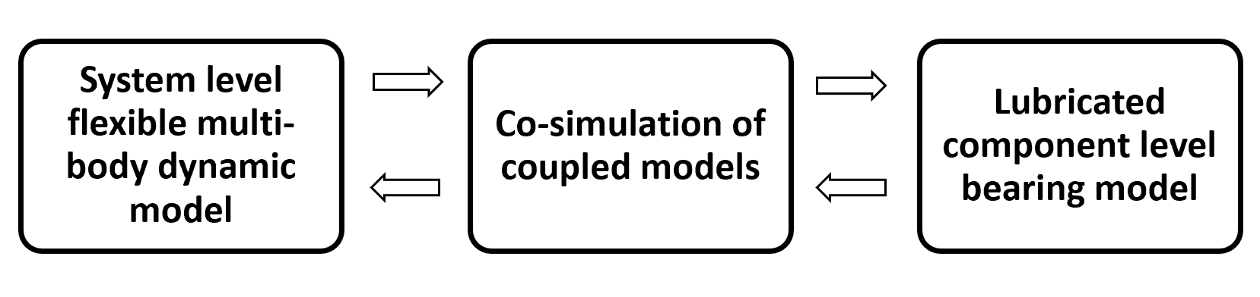

Figure 1 - Flowchart of models

## System Level Flexible Multi-Body Dynamic Model

The system level model is developed in AVL EXCITETM Power Unit. This consists of a flexible shaft, supported by two cylindrical roller bearings in a rigid housing. The shaft has the same geometry and material properties as the shaft used in the High-Speed Roller Bearing Rig [1] and is represented by an FE model using a reduced structure matrix. The cylindrical roller bearings act as joints between the shaft and housing and are represented by a Link to MATLAB®. This joint connects the inner race connection node on the shaft with the outer race connection node on the housing for each bearing.

The shaft is constrained to lateral degrees of freedom only in initial studies. This permits lateral motion in both vertical, , and horizontal, , directions, and rotation about the x-axis. External load is applied to the shaft at the load application point, shown with a green marker in Figure 2. This can be applied as a time-varying input force, to simulate gear mesh excitation for example, or as a static load. Rotational speed is input as a boundary condition and transferred to the shaft via a coupling. The location of the bearings within their housings are also shown in Figure 2, with their connections indicated by the red markers.

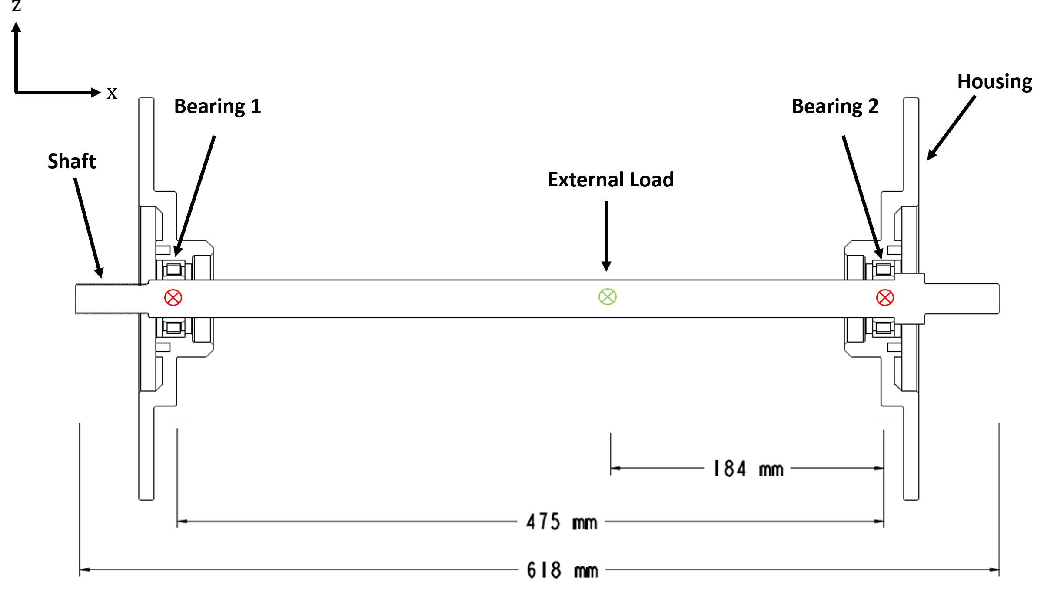

Figure 2 - 2D representation of flexible shaft model

In typical operation containing flexible structures, it is possible for both inner and outer races of a rolling element bearing to move when subject to load. For this analysis, however, it is sufficient to fix the outer race in space and consider only the displacement of the inner bearing race [2]. The housing in this study is treated as a rigid body of infinite stiffness, therefore the race dynamics of the bearing are influenced only by the motion of the flexible shaft in the model. The loading on the inner race is reacted by the rolling elements on the inner raceway. This must therefore be solved to achieve an equilibrium.

Table 1 contains a list of bodies withing the system mode, whether they are rigid or flexible, and active degrees of freedom assigned to them for initial studies. Table 2 contains information on the joint types and which bodies they connect.

Table 1 - Bodies in System Level Model

|  |  |  |
| --- | --- | --- |
| **Body** | **Type** | **Active DOF** |
| Shaft | Flexible | T2, T3, R1 |
| Housing | Rigid | None |
| Spindle | Rigid | None |

Table 2 - Joints in System Level Model

|  |  |  |
| --- | --- | --- |
| **Joint** | **Type** | **Connected Bodies** |
| Bearing 1 | Link to MATLAB® (Lubricated Cylindrical Roller Bearing) | Shaft & Housing |
| Bearing 2 | Link to MATLAB® (Lubricated Cylindrical Roller Bearing) | Shaft & Housing |
| Coupling | ROTX – Rotational Coupling | Shaft and Spindle |

### Governing Equations

Within the model the shaft is treated as a body having linear elastic behaviour, whilst the housing is treated as a rigid body. The bearings act as connections between the bodies and are modelled via non-linear contact forces acting between the components.

The shaft in this model undergoes both translational and rotational motion. Two types of body motion are therefore considered:

* Vibration equations for small motions of components
* Global motion of components

The shaft is represented by a condensed finite element model and is discretized into a sufficiently high number of partial masses or sub-bodies. The total elastic deformation of the shaft is represented by translational displacements and rotational distortion components of these individual partial masses. The mathematical modelling used in the FMB solver is based on Newton’s equations of motion and Euler’s equation of angular momentum.

|  |  |
| --- | --- |
|  | [1] |
|  | [2] |

where and represent the mass and inertia tensors of the partial mass, . The vectors of displacement and angular velocity are represented by and respectively and are related to the centre of gravity of the partial mass. The force and moment vectors, and , must be fulfilled for all partial masses in the body.

The matrices of the structures must be solved in a body-fixed coordinate system and are transformed into the relative (reference) coordinate system using vector rotations of the origin of the reference (body fixed coordinate system) relative to the origin of the absolute coordinate system.

The combination of displacement and rotations of the body takes the form:

|  |  |
| --- | --- |
|  | [3] |

where represents the block-diagonal mass matrix, consisting of the sub-matrices that make up each partial mass of the full body. is itself a block diagonal matrix, containing the mass of the sub-body, , which is multiplied by a 3x3 unit vector, , and the tensor of inertia that corresponds to that partial body, .

|  |  |
| --- | --- |
|  | [4] |

in equation 3 represents the second derivative of the displacement vector of all partial masses, . Each element of this vector has, itself, 6 elements associated with it that represent the 6 degrees of freedom – 3 rotational and 3 translational ().

The sub-vectors of force, , contain the forces and moments acting on each sub-body. These are split into a sum of internal force terms, , external force terms, , and non-linear inertia terms, . As with the partial mass terms, these also have 6 elements each, representing the 6 degrees of freedom:

|  |  |
| --- | --- |
|  | [5] |

where each component of force, is evaluated using the linear-elastic approach.

|  |  |
| --- | --- |
|  | [6] |
|  | [7] |

where and k represent the damping and stiffness coefficients, respectively.

Grouping the damping and stiffness coefficients into one matrix gives the equation of motion after rearrangement. This equation represents the behaviour of the total system of rigid partial masses and considers both general global motion and small body motion:

|  |  |
| --- | --- |
|  | [8] |

On the right-hand side of the equation, the vector of external forces and moments, , is the sum of exciting joint forces, , and external loads, .

|  |  |
| --- | --- |
|  | [9] |

External loads and moments applied to the shaft are determined functions given in time and can be input as time-varying or static loads on the system. The non-linear excitation terms, , resulting from the connecting joints are given, in the case of this model, by the component level bearing model.

## Co-Simulation of Coupled Models

A coupled simulation approach is employed to implement the lubricated components level bearing model within the flexible multi-body dynamic (FMBD) environment. AVL EXCITETM contains integrated “Link to MATLAB” functionality, whereby joints within the model can be replaced with a user function created in MATLAB Simulink®.

Nodal displacements, , and velocities,, at the bearing locations are output from the dynamic model at each time step and used as boundary conditions within a lubricated component level bearing model. This model returns resultant forces and torques on the inner race of each bearing, which are then used to solve the equation of motion (equation 8) within the dynamic model.

### Link to MATLAB

**Connected Degrees of Freedom**

Connections are created between bodies in the FMBD software using pins. Pins are assigned to specific nodes on the shaft and housing. The pins transmit a 6-element vector that describe the 6 DOFs (degrees of freedom) of the connection point. The first 3 elements translational degrees of freedom, whilst the latter represent rotational degrees of freedom. This are concatenated into a single vector that is then passed to MATLAB®.



Figure 3 - Connection pins and degrees of freedom

Two vectors are transferred from EXCITETM Power Unit to MATLAB®: one containing displacement information in all 6 DOFs and the other containing velocity information. Force vectors of equal size are then computed within the component level model in MATLAB® and returned to EXCITETM Power Unit.

The connection to MATLAB® is facilitated via an S-function, therefore a Simulink® model is required. A generic block developed by AVL, the EXCITE Power Unit Simulink block, is used for this purpose:

**Output Port**

Output data from the FMBD model is organised in vector format, of size 6n where n is the total number of connections being passed from MATLAB® to EXCITETM Power Unit. To access data for each connection, and then split this into specific degrees of freedom, two levels of Demux elements are needed.

1. The first level of Demux splits the output vector into n number of pins, of size 6 to represent the degrees of freedom at each pin.
2. The second level of Demux blocks splits the 6-element vector for each pin into the 6 scalar values that represent the data for each degree of freedom. These can then be used as inputs to the MATLAB® function block within the Simulink® model.

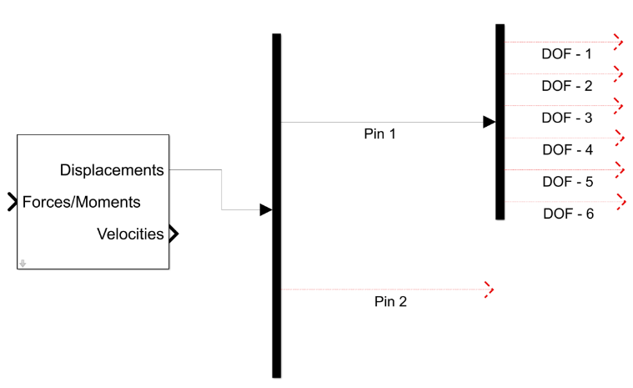

Figure 4 - Output port Demux blocks and degrees of freedom

**Input Port**

At the input port to the EXCITETM Power Unit Simulink block, a vector of 6n elements must be passed. This requires two Mux blocks: the first to combine the degrees of freedom of each pin, and the second to combine all of these connection vector into a single vector that is passed to EXCITETM Power Unit.

Figure 5 - Input port Mux blocks and degrees of freedom

To integrate the lubricated bearing model into the Simulink® model, the MATLAB® Function block is used. The inputs to the block are defined at the beginning of the function, and the appropriate degrees of freedom are connected to the block in the order of which they appear in the script. The function blocks and hence lubricated bearing models are highlighted in Figure 6, as well as the ports and the demux blocks that split the degrees of freedom.

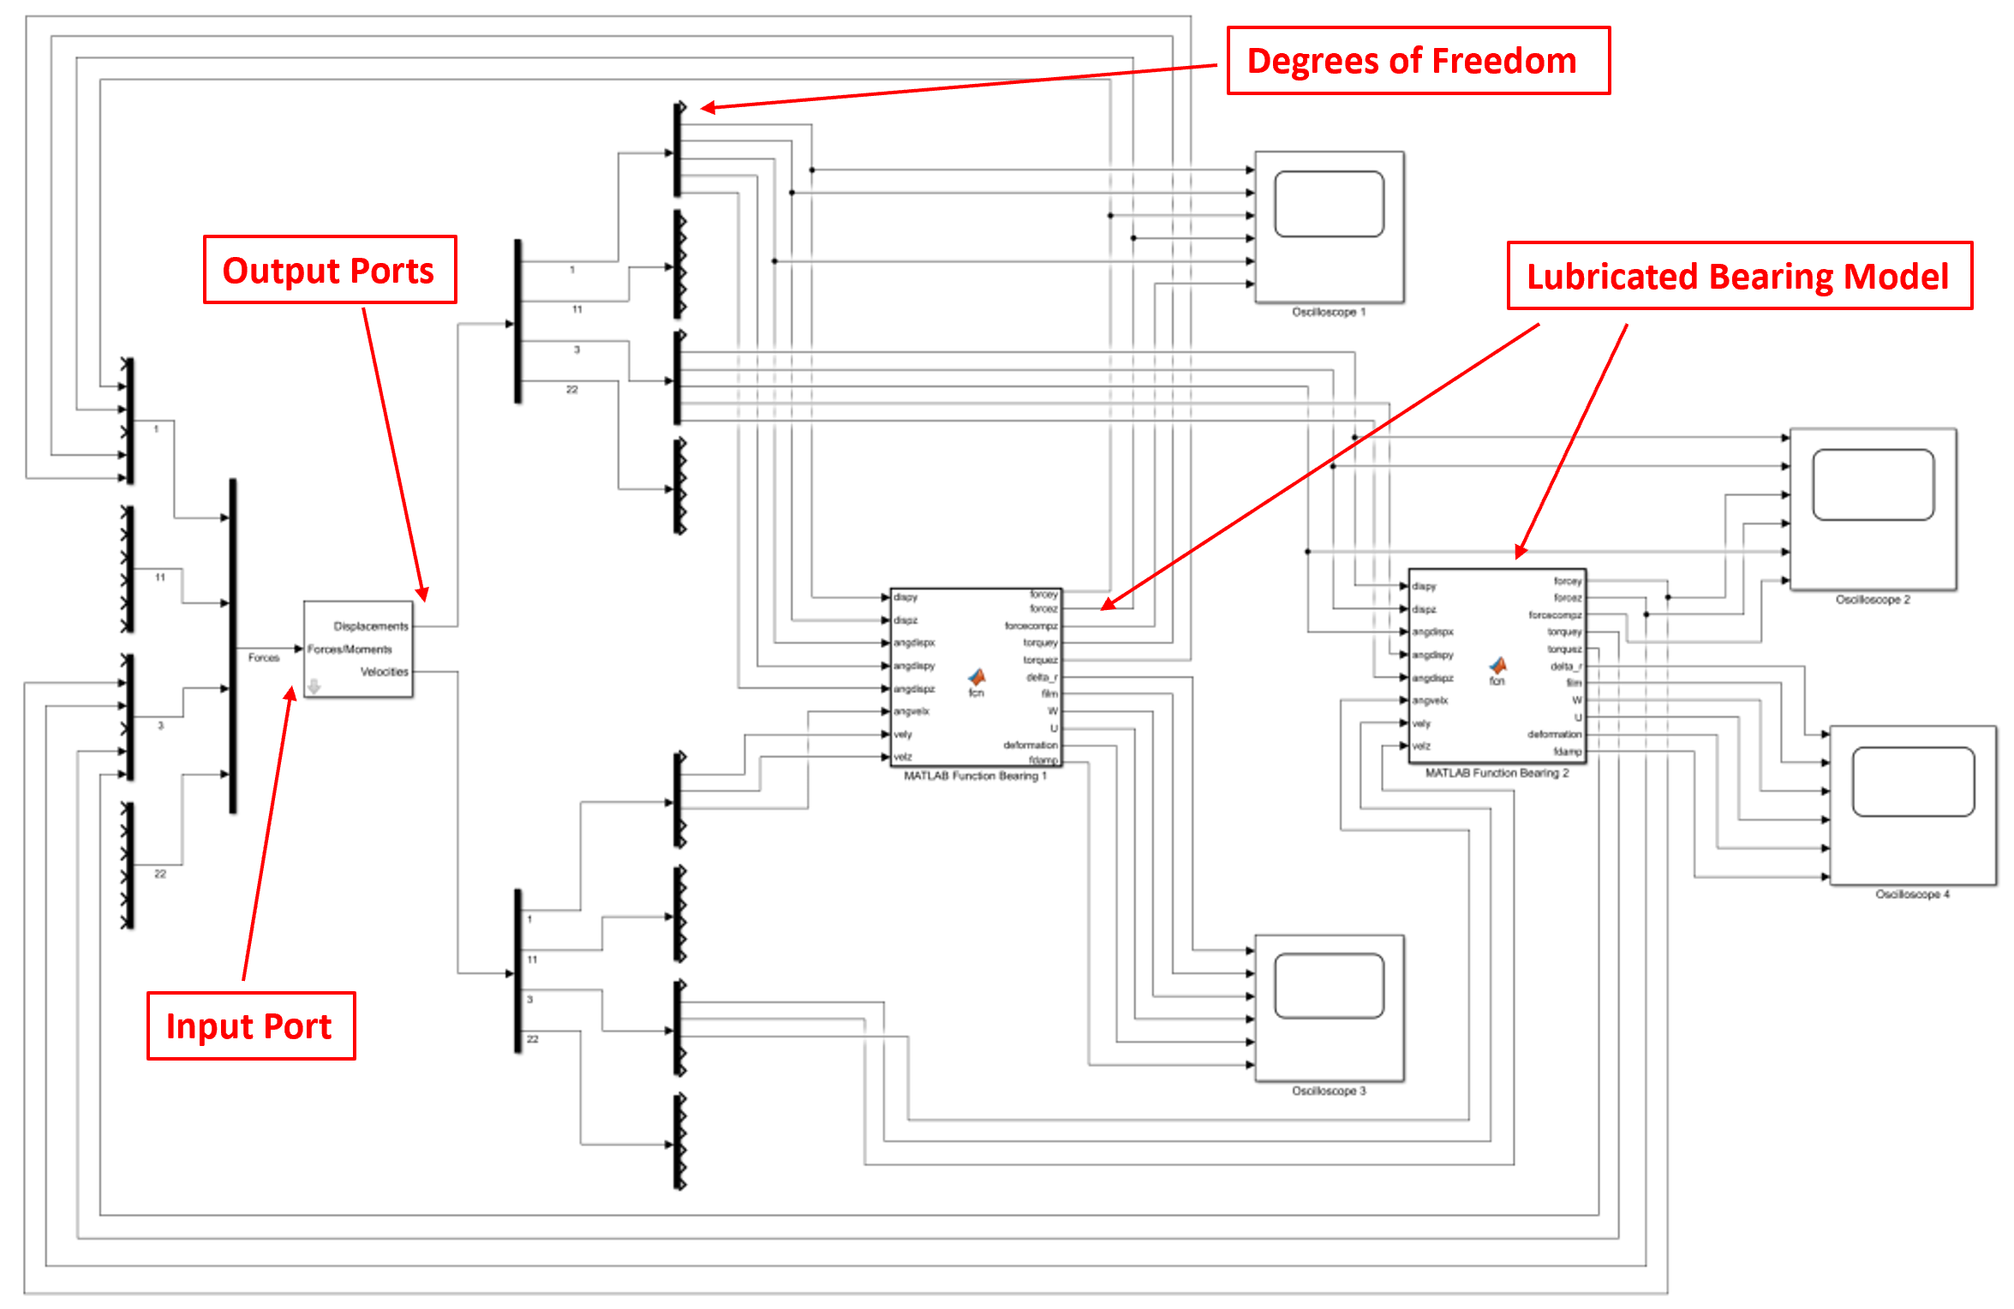

Figure 6 - Simulink model layout

The coupled simulation supported by EXCITETM Power Unit is explicit in nature. This means that there is no iteration at each time step between the dynamic solver and the bearing model. A sufficiently fine time step is therefore required to prevent numerical divergence of results due to error accumulation. It was found that a time step of 1e-6 s was fine enough to ensure numerical convergence, whilst also remaining computationally efficient.

## Lubricated Component Level Bearing Model

The component level model is connected to the system level model using the method described in the previous section. The bearing model receives a displacement, , and velocity, , vector for each of the connection nodes between the shaft and housing at each time step of the dynamic simulation. This is split into the 6 degrees of freedom and used within the bearing model. The solution mechanism is described in this section.

**Assumptions in model:**

* Bearing races are considered as rigid due to the high stiffness of the housing and shaft. No structural deformation of these occurs, only elastic deformation associated with the concentrated contacts.
* Friction in this model is neglected due to its low contribution to internal rolling element load distribution.
* Cage forces are neglected due to their low loads.
* Centrifugal loads are not accounted for as they are negligible in comparison to the overall contact loads.
* Pure rolling occurs, i.e. no slip or skid, and cage motion is governed by geometric dimensions of the bearing. This is valid for sufficiently loaded bearings.
* The stiffness and damping of the EHL film is neglected due to its rigid-like stiffness, which is several orders of magnitude higher than the Hertzian contact [3] [4].

### Force-Deflection Relationship

The displacement vector from each node, , is split into 6 DOF. For the lateral DOF model, translations in and are considered, as well as angular displacement around the rotational axis, . A schematic of the bearing is shown in Figure 7.

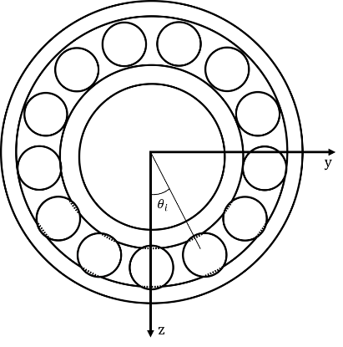

Figure 7 - Bearing schematic

Between the roller and raceways, under sufficient load, the pressures in the non-conformal contact are high enough to cause elastic deformation of the surfaces and a significant increase in lubricant viscosity. This leads to the generation of an EHL contact. The stiffness of the EHL film is typically 1-2 orders greater than the stiffness of the contacting bodies. As a result of this, the stiffness of the film can be neglected [3] [4], and it can be modelled as a rigid element that is present between roller and race.

The contact deformation, , is therefore a function of the displacement of the inner bearing race, angular position of the roller, , thickness of the EHL film, , and any clearance or radial preload, , within the bearing [5]:

|  |  |
| --- | --- |
|  | [10] |

In the case of a rolling element, a cylindrical body of finite length, the contact problem is non-Hertzian. The surfaces cannot be modelled as locally quadratic due to the presence of crowned (rounded) edges [6] . For the point contact case, Hertz [7] proposed an analytical solution for the load-deflection relationship – however, no such relationship was provided for the line contact. A relationship to obtain resultant load on individual elements based on their deflection was needed. This has been addressed by many authors, with a more comprehensive history provided in the literature review. The most widely used of these techniques is the contact slicing technique. Whilst this does not reflect edge stress concentrations, these stresses are only distributed over a small area and hence can be neglected for the purpose of force equilibrium [8]. In general, this technique is favoured for its simplicity, speed, and sufficient accuracy.

Andreason [9] developed the slicing technique for modelling non-Hertzian line contacts. The roller is sliced into smaller sections along its length. The contact load intensity at each slice is obtained as the one on the roller should the roller be subject to a contact compression equal to the one occurring on the slice considered over its entire length.

Modelling the roller-race contacts as a line contact between a cylindrical roller and a flat surface, Lundberg’s [10] expression between contact force per unit length, , and deformation, , was used. This assumes a uniform pressure distribution along the length of the contact, and an elliptical one across it. This neglects side leakage along the contact () due to the contact dimensions in this direction being much larger than dimensions across it ( ). This is valid apart from the small regions at the edges of the contact.

|  |  |
| --- | --- |
|  | [11] |

where is the equivalent elastic modulus of the two materials and is the active length of each slice along the roller.

From equation 11, an equation based on empirical data can be approximated to calculate contact forces per unit length of an individual slice along the roller-race contact. This is valid if there is no separation of the bodies, ie. the contact deformation does not become negative.

|  |  |
| --- | --- |
|  | [12] |

where represents the slice number. It is assumed that total contact deflection is shared equally between inner and outer races.

The application of this slicing technique within the roller bearing model was validated against open literature. de Mul et al. [2] compared results obtained from an experimental rig with numerical results calculated using bother the approximate slicing technique and the sophisticated non-Hertzian technique [11]. By replicating the geometry of the test bearing used in their analysis, the application of Andreason’s slicing technique within the model used for this analysis could be validated. Results of this validation within a realistic loading region are shown in Figure 8.

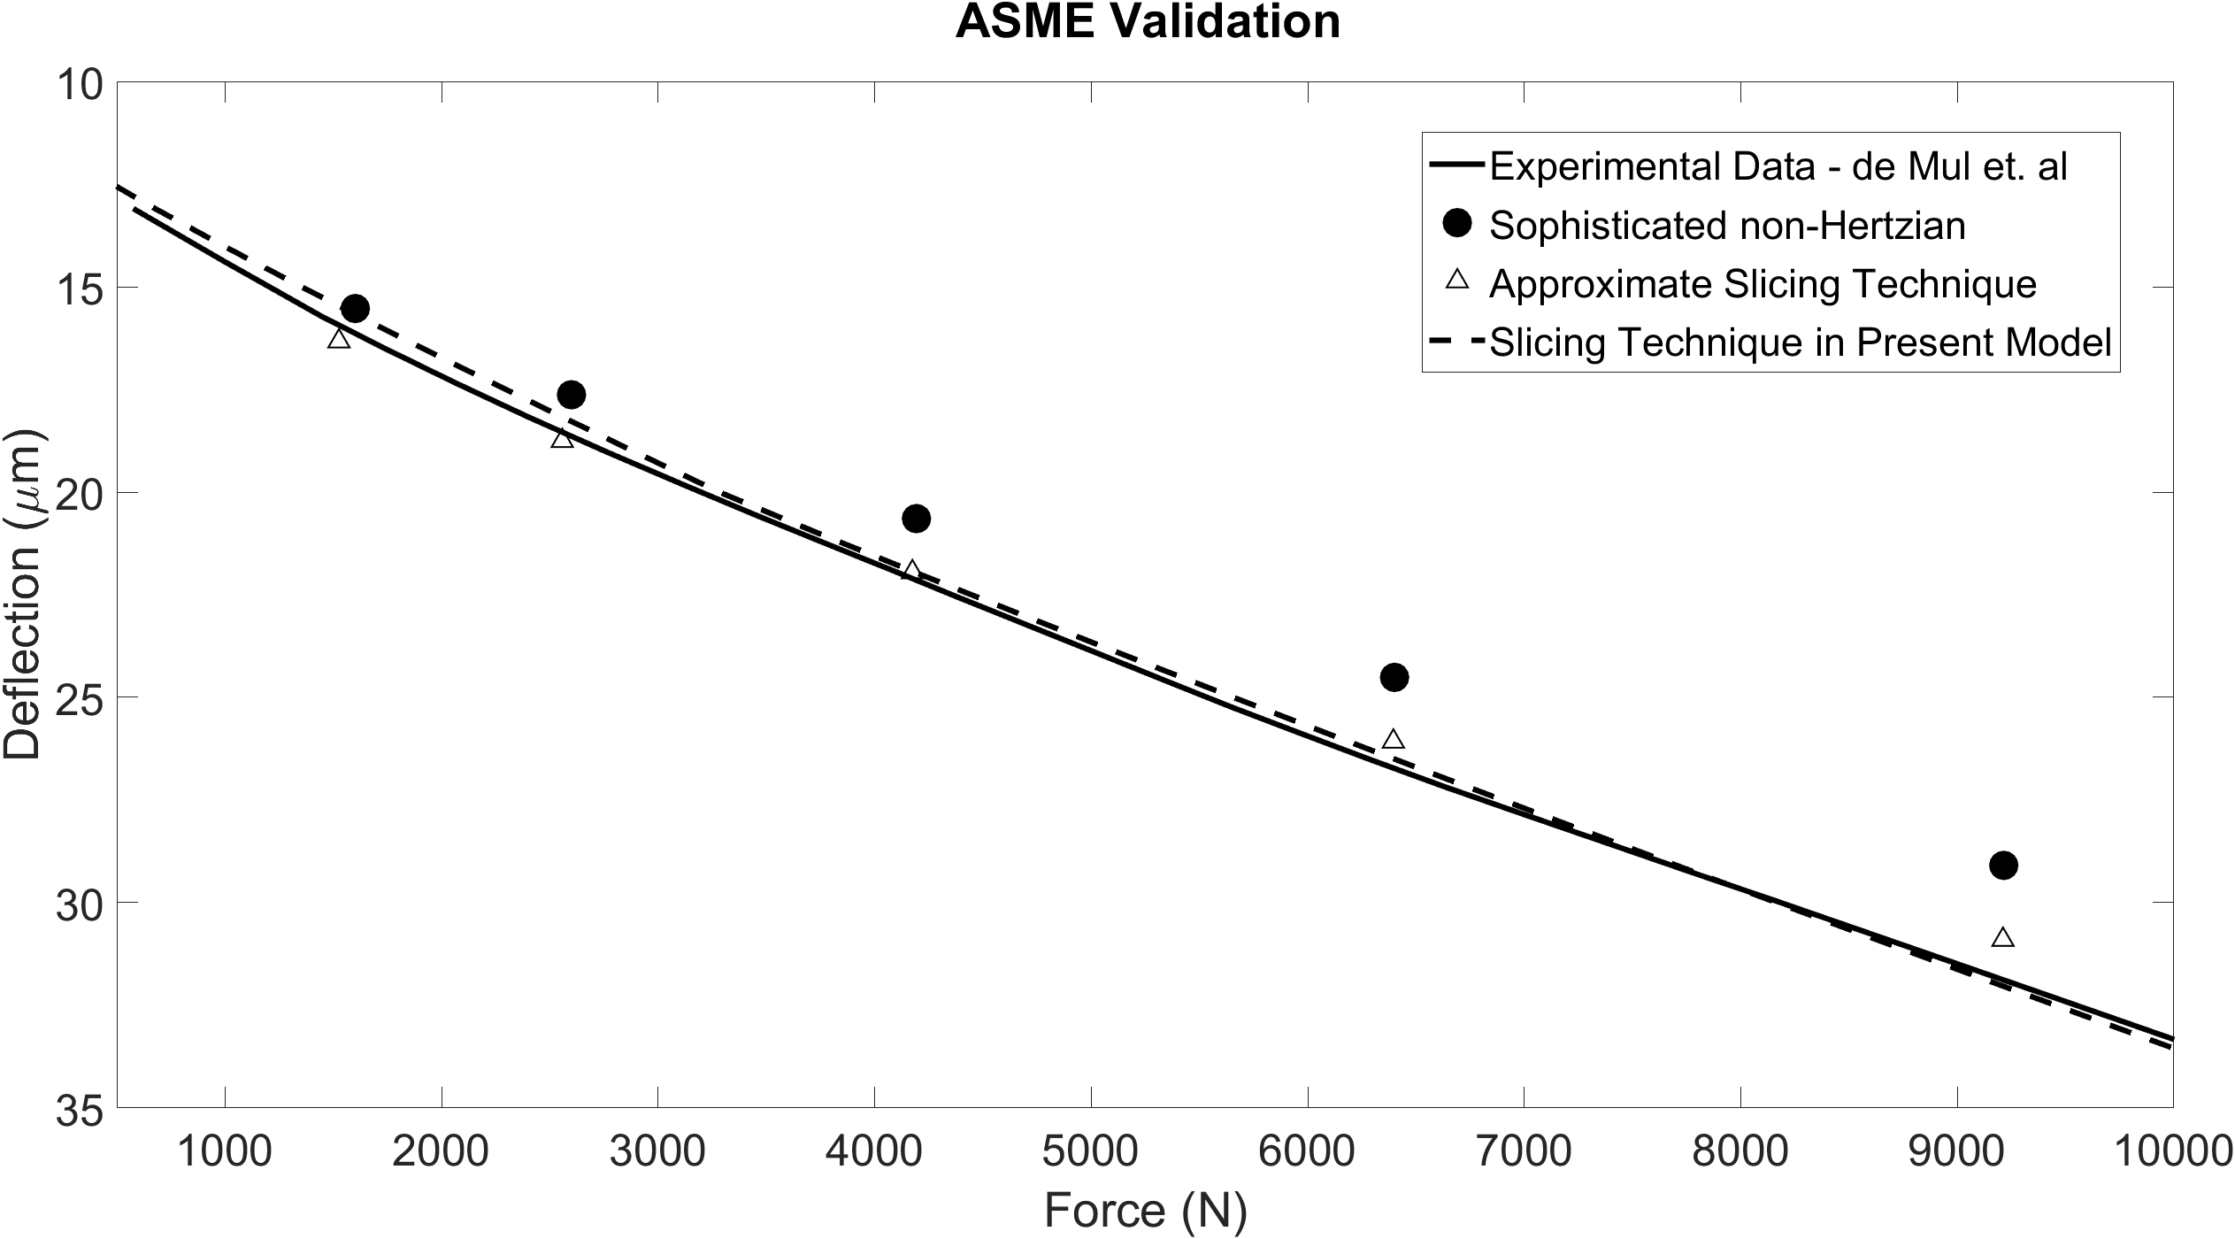

Figure 8 - Validation of slicing technique used in the model against experimental data by de Mul et. al [2] and the Sophisticated non-Hertzian Technique [11]

The total contact load and moment are then obtained by summing the contributions from all loaded slices:

|  |  |
| --- | --- |
|  | [13] |
|  | [14] |

with being the slice length. This simple method is a much faster way of calculating contact load and moment than more sophisticated methods by de Mull [11].

At each time step of the analysis, these calculations are performed for each individual roller in the complement. The total bearing force acting on the inner race is solved by splitting the total contact force on each roller into its components and summing their contributions.

|  |  |
| --- | --- |
|  | [15] |
|  | [16] |

### Damping

Vibration transfer through a roller bearing is influenced by the stiffness and damping behaviour of the contacts between rolling elements and raceways.

Damping within a rolling element baring arises from a variety of sources. Assuming a dry ball bearing, material damping as a result of asperity contact, frictional damping, and dissipative losses at interfaces can equate to a damping coefficient of 1% [12]**.** The addition of lubricant can introduce EHL film damping effect which can equate to a damping ratio of 2%. Increasing contact area, i.e., more elements, larger element size and type of element also increases the damping ratio. Dietl et. al found that within a tapered roller bearing, as speed increased above 2 000 rpm, the EHL damping ratio began to level at around 4%, with an additional 1% arising from material damping.

Damping coefficient can be obtained as a factor of contact stiffness. This is beneficial to the numerical convergence of the model in the initial stages when the system is released from stationary. The following relationship is used to find the coefficient, :

|  |  |
| --- | --- |
|  | [17] |

where K is the contact stiffness, and the damping factor, , is in the range of as reported by Krämer [13].

|  |  |
| --- | --- |
|  | [18] |

The contact damping force for each element, , is split into and components, and subtracted from the element reaction force.

### Implicit Tribological Model

As detailed in equation 10, the EHL film plays a critical role in the total deflection of the roller race contact. This is the case should there be no separation of contacting bodies. However, under variable loading conditions and with sufficient bearing clearance, there may also be separation of the bodies resulting in the hydrodynamic regime of lubrication.

At each time step of the analysis, the dry deflection of each roller is calculated assuming no lubricant film is present.

indicates complete separation of the roller and race. In this instance, the lubricant is assumed to fill the separation gap, with the film thickness value equalling the magnitude of the separation:

|  |  |
| --- | --- |
|  | [19] |

Under this condition, the lubrication is in the hydrodynamic regime. The hydrodynamic lubricant reaction load was derived by Rahnejat [14], and is given by:

|  |  |
| --- | --- |
|  | [20] |

where is the half length of the contact, is the speed of lubricant entrainment into the contact, is the lubricant viscosity, is the reduced radius of the roller and race and is lubricant film thickness.

indicates deflection at the roller-race contact. This means that contact pressure is sufficiently high for the lubrication regime to be elastohydrodynamic. For the elastohydrodynamic regime, an iterative process is performed to solve film thickness. This is due to the contribution of EHL film towards deformation and consequently the load in the contact.

The extrapolated central film thickness for a line contact is therefore obtained [15] from:

|  |  |
| --- | --- |
|  | [21] |

where the following dimensionless parameters are used:

|  |  |
| --- | --- |
|  | [22] |

where is the reduced radius of the contact, is the total length of the roller, is the speed of entraining motion into the contact and is the contact load. Assuming pure rolling, the speed of entraining motion is given by:

|  |  |
| --- | --- |
|  | [23] |

An iterative process is used to calculate load on the roller based on total deflection including lubricant film (back to eq.10). At each time step where an EHL film is present, convergence criteria must be met before the total bearing force is returned to the system level model and the equations of motion are solved:

|  |  |
| --- | --- |
|  | [24] |

where represents the iteration number.

Results

Dynamic simulations were performed at speed intervals of 1 000 rpm from 1 000 rpm up to 12 000 rpm. A static radial load of 1000 N was applied to the load application point on the shaft. Results from the steady state periods of the time-domain signals have been analysed. The purpose of these studies is observe the difference in dynamic response between dry models where no EHL film is present ( in equation 10), and lubricated models across a range of speeds.

The bearing specifications are described in Table 3. Lubricant and material properties are specified in Table 4.

Table 3 - Bearing Specification

|  |  |
| --- | --- |
| Inner Race Bore | 25 mm |
| Inner Race Diameter | 31.5 mm |
| Outer Race Diameter | 46.5 mm |
| Roller Diameter | 7.5 mm |
| Roller Length | 15 mm |
| Number of Rollers | 12 |
| Radial Interference | 0 µm |

Table 4 – Lubricant and Material Properties

|  |  |
| --- | --- |
| Pressure Viscosity Coefficient () | 2.1 10-8 Pa-1 |
| Atmospheric lubricant dynamic viscosity () | 0.08 Pa.s |
| Lubricant inlet density () | 833.8 kg/m |
| Modulus of elasticity of contacting solids | 210 GPa |
| Poisson’s ratio of contacting solids | 0.3 |

## Dry vs Lubricated Roller Contact Conditions

At speeds of 4 000, 8 000 and 12 000rpm, the contact conditions of an individual roller and the raceway have been analysed for the dry and lubricated models. These are plotted for a fixed time period of 0.2s in the steady state region of the dynamic results. Contact deformation and resultant normal force are plotted to show the force-deflection relationship. The linearised normal contact stiffness is computed for each speed to observe how this fluctuates through the roller orbit for each model. The contact force and corresponding film thickness are plotted to also quantify the EHL film thickness and the effect that the fluctuating contact load has on its magnitude.

Results for 4 000, 8 000 and 12 000 rpm are shown in Figure 9, Figure 10 and Figure 11 respectively.

|  |  |
| --- | --- |
| **4 000 rpm Lubricated Results** | **4 000 rpm Dry Results** |
| Figure 12a - 4 000 rpm Lubricated - Contact Deformation and Contact Force | Figure 12b - 4 000 rpm Dry - Contact Deformation and Contact Force |
| Figure 12c - 4 000 rpm Lubricated - Normal Contact Stiffness | Figure 12d - 4 000 rpm Dry - Normal Contact Stiffness |
| Figure 12e - 4 000 rpm Lubricated - Contact Force and Corresponding Film Thickness | Figure 12f - 4 000 rpm Dry - Contact Force and Corresponding Film Thickness |

Figure 9 - 4 000 rpm Lubricated and Dry Contact Results

|  |  |
| --- | --- |
| **8 000 rpm Lubricated Results** | **8 000 rpm Dry Results** |
| Figure 11a - 8000 rpm Lubricated - Contact Deformation and Contact Force | Figure 11b - 8 000 rpm Dry - Contact Deformation and Contact Force |
| Figure 11c- 8 000 rpm Lubricated - Normal Contact Stiffness | Figure 11d - 8 000 rpm Dry - Normal Contact Stiffness |
| Figure 11e- 8 000 rpm Lubricated - Contact Force and Corresponding Film Thickness | Figure 11f - 8 000 rpm Dry - Contact Force and Corresponding Film Thickness |

Figure 10 - 8 000 rpm Lubricated and Dry Contact Results

|  |  |
| --- | --- |
| **12 000 rpm Lubricated Results** | **12 000 rpm Dry Results** |
| Figure 12a - 12 000 rpm Lubricated - Contact Deformation and Contact Force | Figure 12b - 12 000 rpm Dry - Contact Deformation and Contact Force |
| Figure 12c - 12 000 rpm Lubricated - Normal Contact Stiffness | Figure 12d - 12 000 rpm Dry - Normal Contact Stiffness |
| Figure 12e - 12 000 rpm Lubricated - Contact Force and Corresponding Film Thickness | Figure 12f - 12 000 rpm Dry - Contact Force and Corresponding Film Thickness |

Figure 11 - 12 000 rpm Lubricated and Dry Contact Results

Analysing the dry (a) and lubricated (b) contact force and deformation results, the peak values for both remain constant at each speed interval due to the absence of the lubricant film. For the lubricated cases, the peak contact force increases from 1050 N to 2175 N. This increase is due to the entrainment of lubricant into the contact that acts as a rigid wedge which adds to the total deformation and hence resultant force. For the 12 000 rpm cases (Figure 11a and Figure 11b), under lightly loaded shaft conditions with zero preload in the bearing, a peak contact force difference of up to 16 times can be seen between the dry and lubricated models. It can also be seen that the contact force reduces to zero in the dry results for all speeds, indicating separation of the rollers and raceways. The contact force fluctuations for the lubricated model show constant positive values, indicating deformation at the roller and raceway contact throughout the entire orbit.

The contact stiffness peak values for the dry models (d) do not change with increasing speed. This is due to the contact deformation remaining almost constant throughout the speed sweep. For the lubricated results (c), the contact stiffness increases with speed. This is due to a greater film thickness at higher speeds resulting in greater contact deformation. As the lubricant film stiffness is 1-2 orders greater than the material stiffness, when the EHL film and material stiffness act in series, the stiffness of the contact is governed by the material stiffness. As the penetration depth into the materials increases with speed, the non-linear force-deflection relationship observed in Figure 8 results in a greater stiffness value at the contact. At 12 000 rpm (Figure 11c and Figure 11d), the contact stiffness magnitude in the lubricated model is 1.35 times greater than the dry model.

The film thickness variation with rotational speed and load is shown in Figure 9e - Figure 11e. As rotational speed increases, the relative surface velocity at the roller race contact increases. This results in a greater amount of lubricant being entrained into the EHL contact. From 4 000 rpm to 12 000 rpm, the film thickness grows by 2.1 µm. The effect of fluctuating load on the thickness can also be observed as the roller enters and exits the loaded region, characterised by the increase, and decrease in contact force. As the roller enters the loaded region, the central film thickness reduces.

## Dry vs Lubricated Speed Sweep Operating Envelopes

In this analysis, periods of the steady state signal at each 1 000 rpm increments have been analysed. The peak-to-peak values for different contact and dynamic conditions have been plotted for both the dry and lubricated cases across the speed sweep. The purpose of this is to clearly show how the bearing and system behaviour varies with speed for both analyses, and why it is crucial that the lubricant film is implicitly modelled to capture these differences at higher speeds. Solid lines represent maximum values from the signal, and dotted lines represent minimum values.

### Inner Race Displacement – Z-Direction

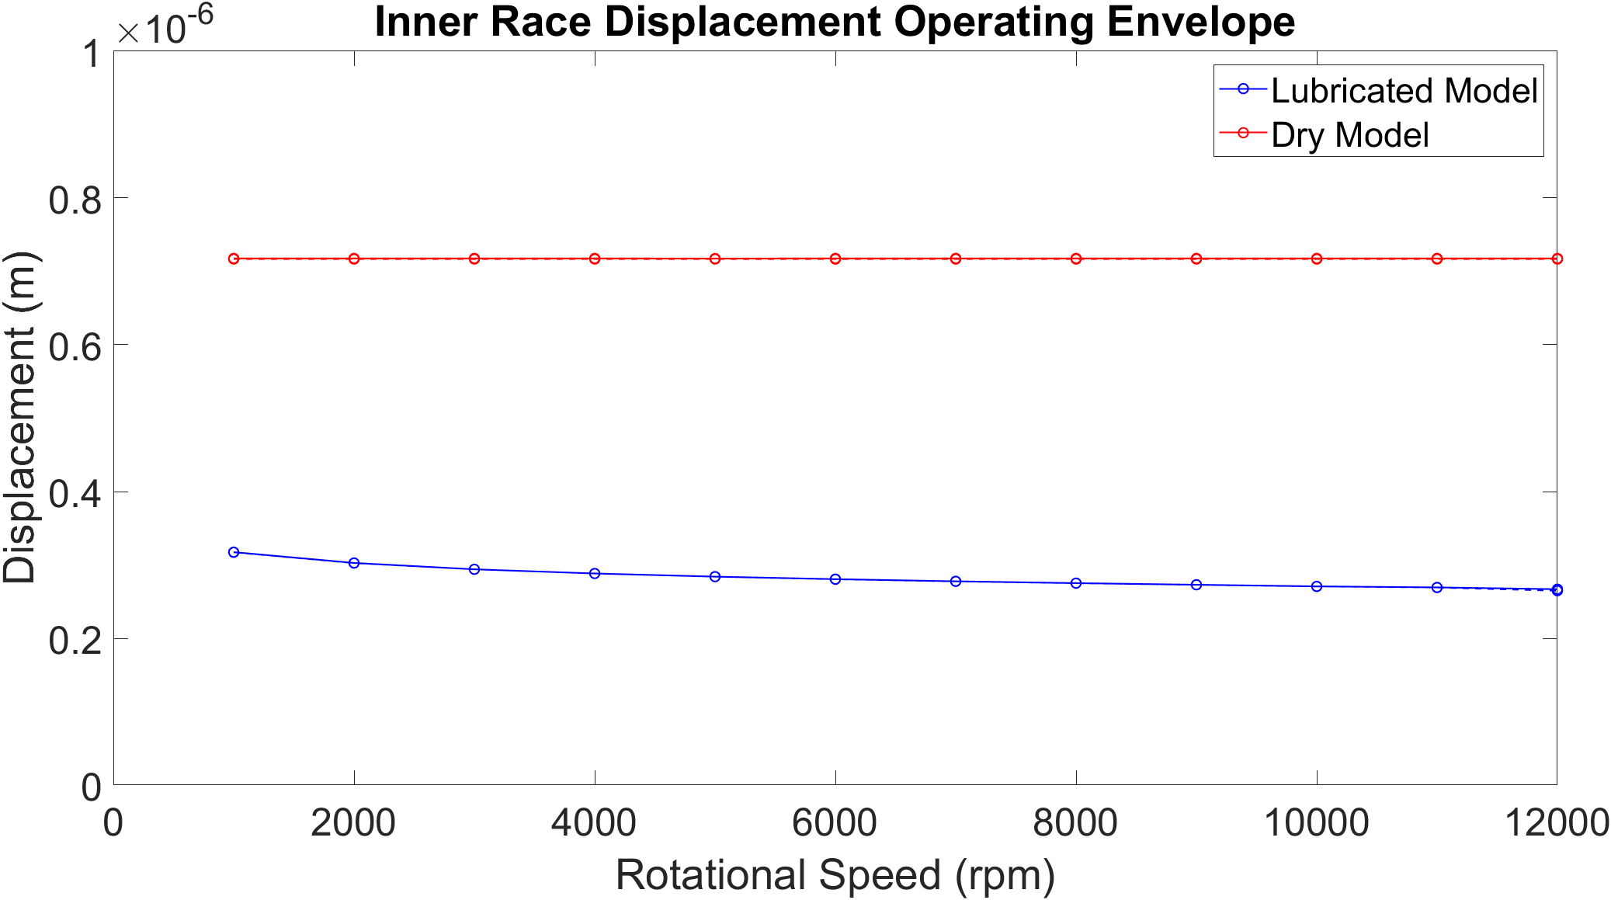

Figure 12 - Inner Race Displacement Operating Envelope - Z-Direction

Displacement of the inner bearing race is shown to be greater for the dry model for the same value of force applied to the inner race. This is a consequence of the greater total stiffness of the bearing in the lubricated model. The inclusion of the rigid lubricant film leads to greater total contact deflection, which leads to a higher contact stiffness at each element due to the non-linear relationship between force and deflection. The combined stiffnesses of all roller-raceway contacts in parallel lead to a greater total bearing stiffness and hence lower inner race displacement for the same applied force. The inner race displacement of the lubricated model also reduces as rotational speed of the shaft increases. This is also a result of contact stiffness increasing with entrainment velocity.

### Inner Race Force – Z-Direction

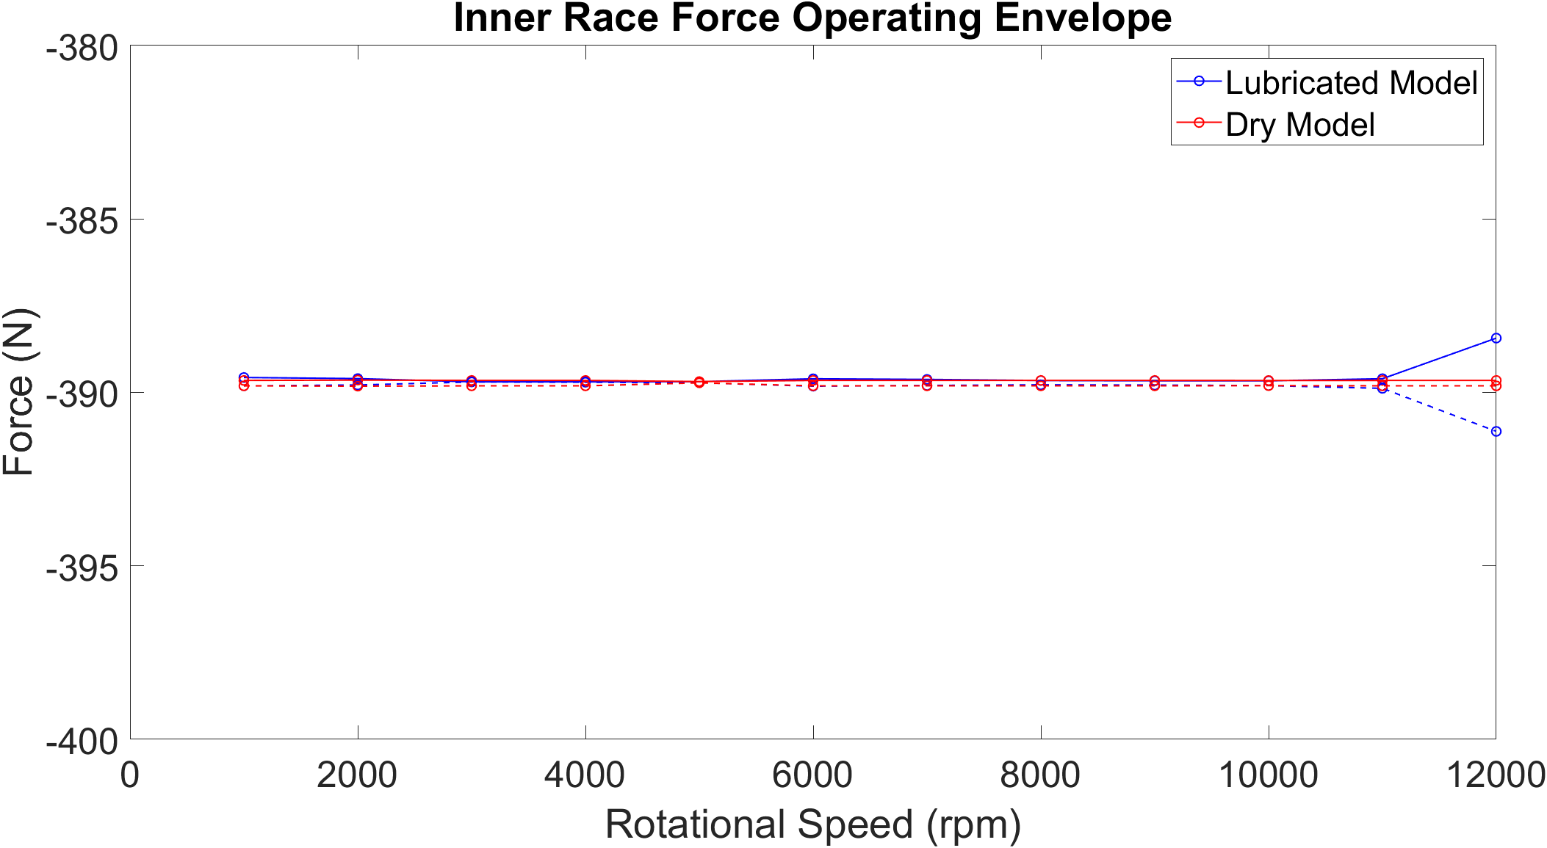

Figure 13 - Inner Race Force Operating Envelope - Z-Direction

For both dry and lubricated models, the inner race reaction force is equal for the speed sweep. This is due to a constant static force being applied to the shaft at every speed increment, with each bearing taking a share of the applied load. Due to the non-central application of force and constraining the shaft to only lateral motion, the bearing (bearing 1) analysed in these results takes a smaller share of the 1 000 N load. The nominal reaction force remains constant throughout the speed sweep, however the fluctuations between minimum and maximum values vary due to small contributions from the flexible shaft.

The contact force is expected to fluctuate to a much greater degree with time-varying input forces and additional flexible elements within the model. The only excitation within the model comes from the rollers entering and exiting the loaded region of the bearings. These contact frequencies do not have enough energy to excite resonances within the flexible shaft or other structures, hence the very steady dynamic response from these initial studies. Higher speeds and loading conditions need to be modelled to assess this further.

### Contact Deformation

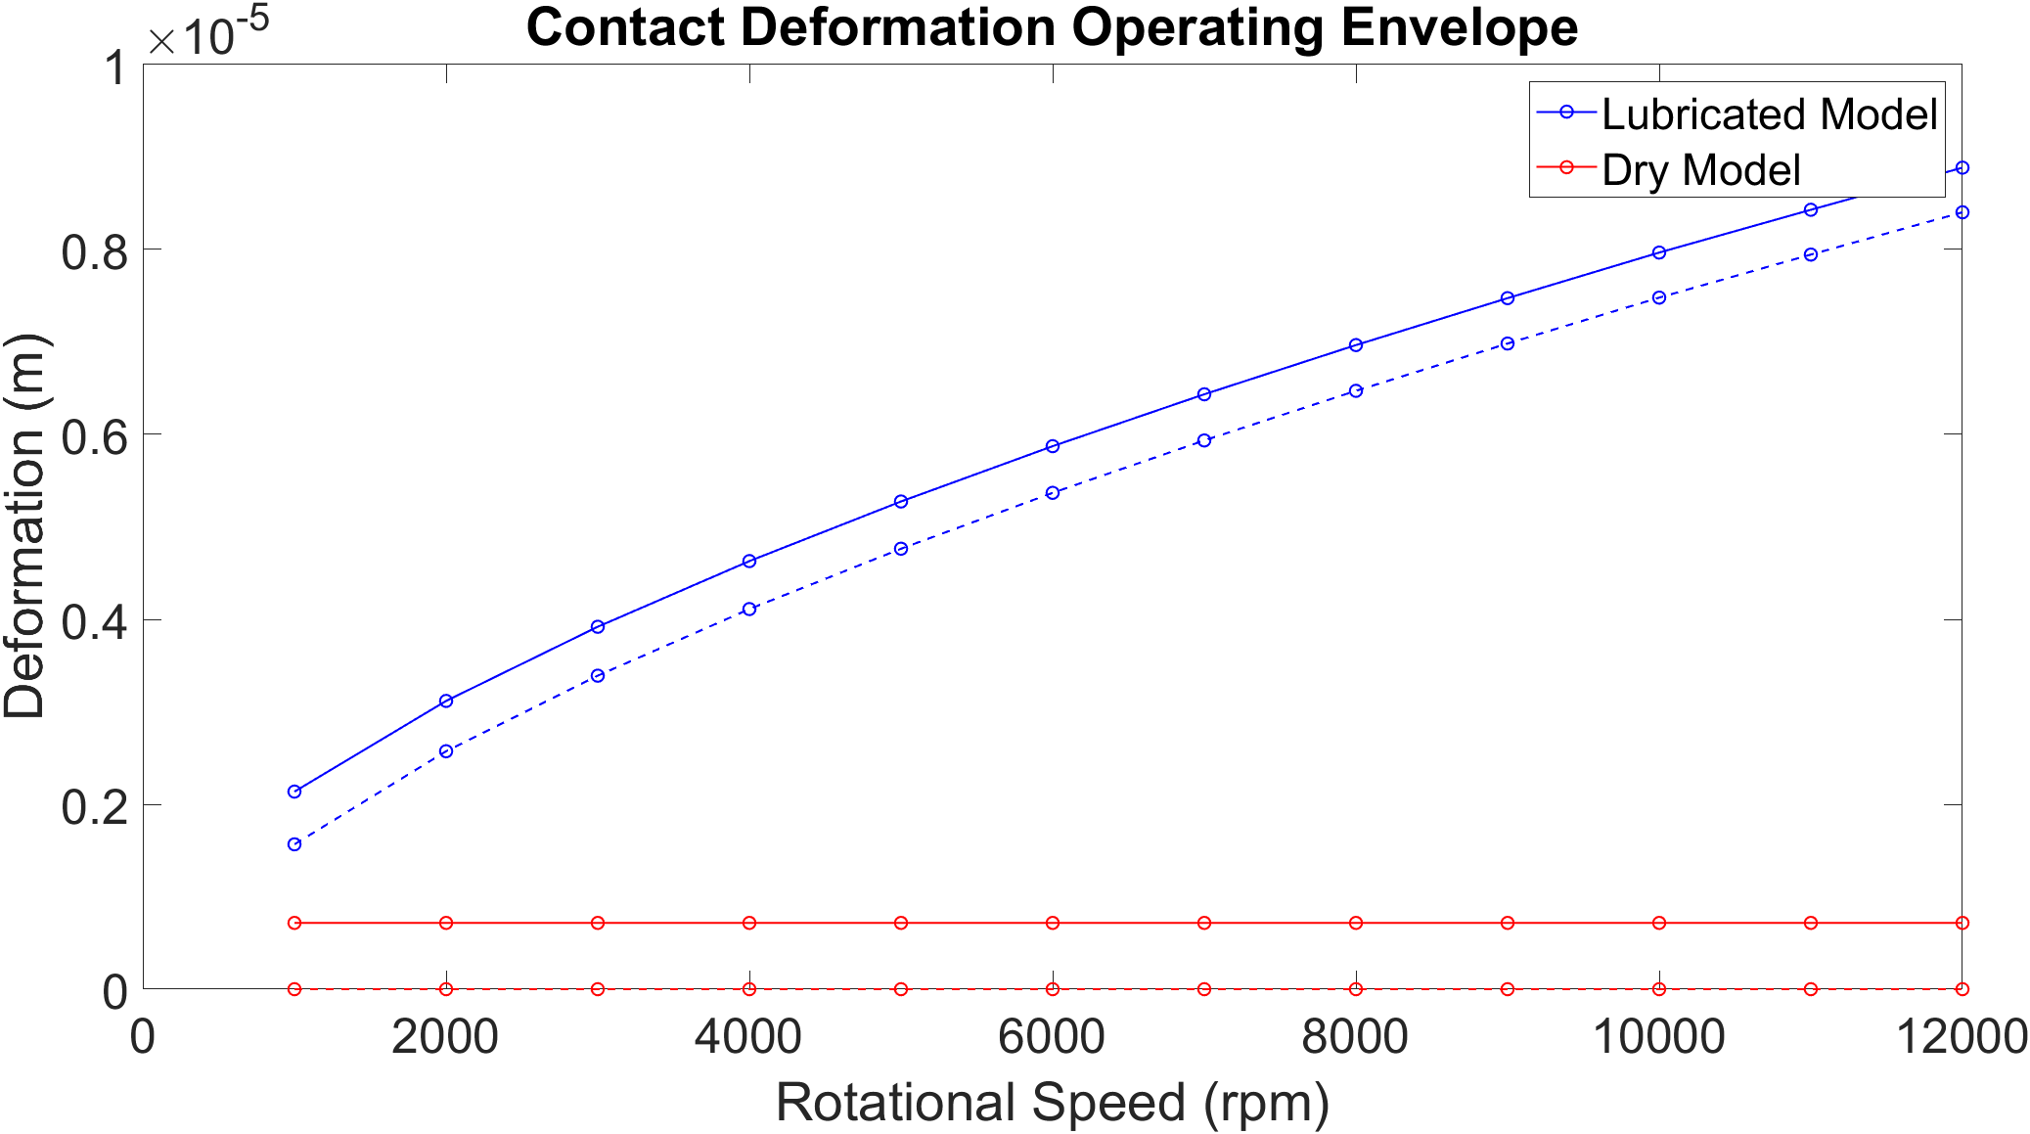

Figure 14 - Contact Deformation Operating Envelope

Analysing the results from the dry analysis, the minimum value of contact deflection reaches zero through all speeds. The reason for this is that the bearing model has no predefined preload. The contact deflection in the loaded region of the dry bearing leads to contact separation in the unloaded region, resulting in zero contact deflection for each roller in periods of their orbit. The deformation for the lubricated models increases with speed due to the higher entrainment velocities resulting in thicker EHL film and hence greater contact deflection.

### Contact Force

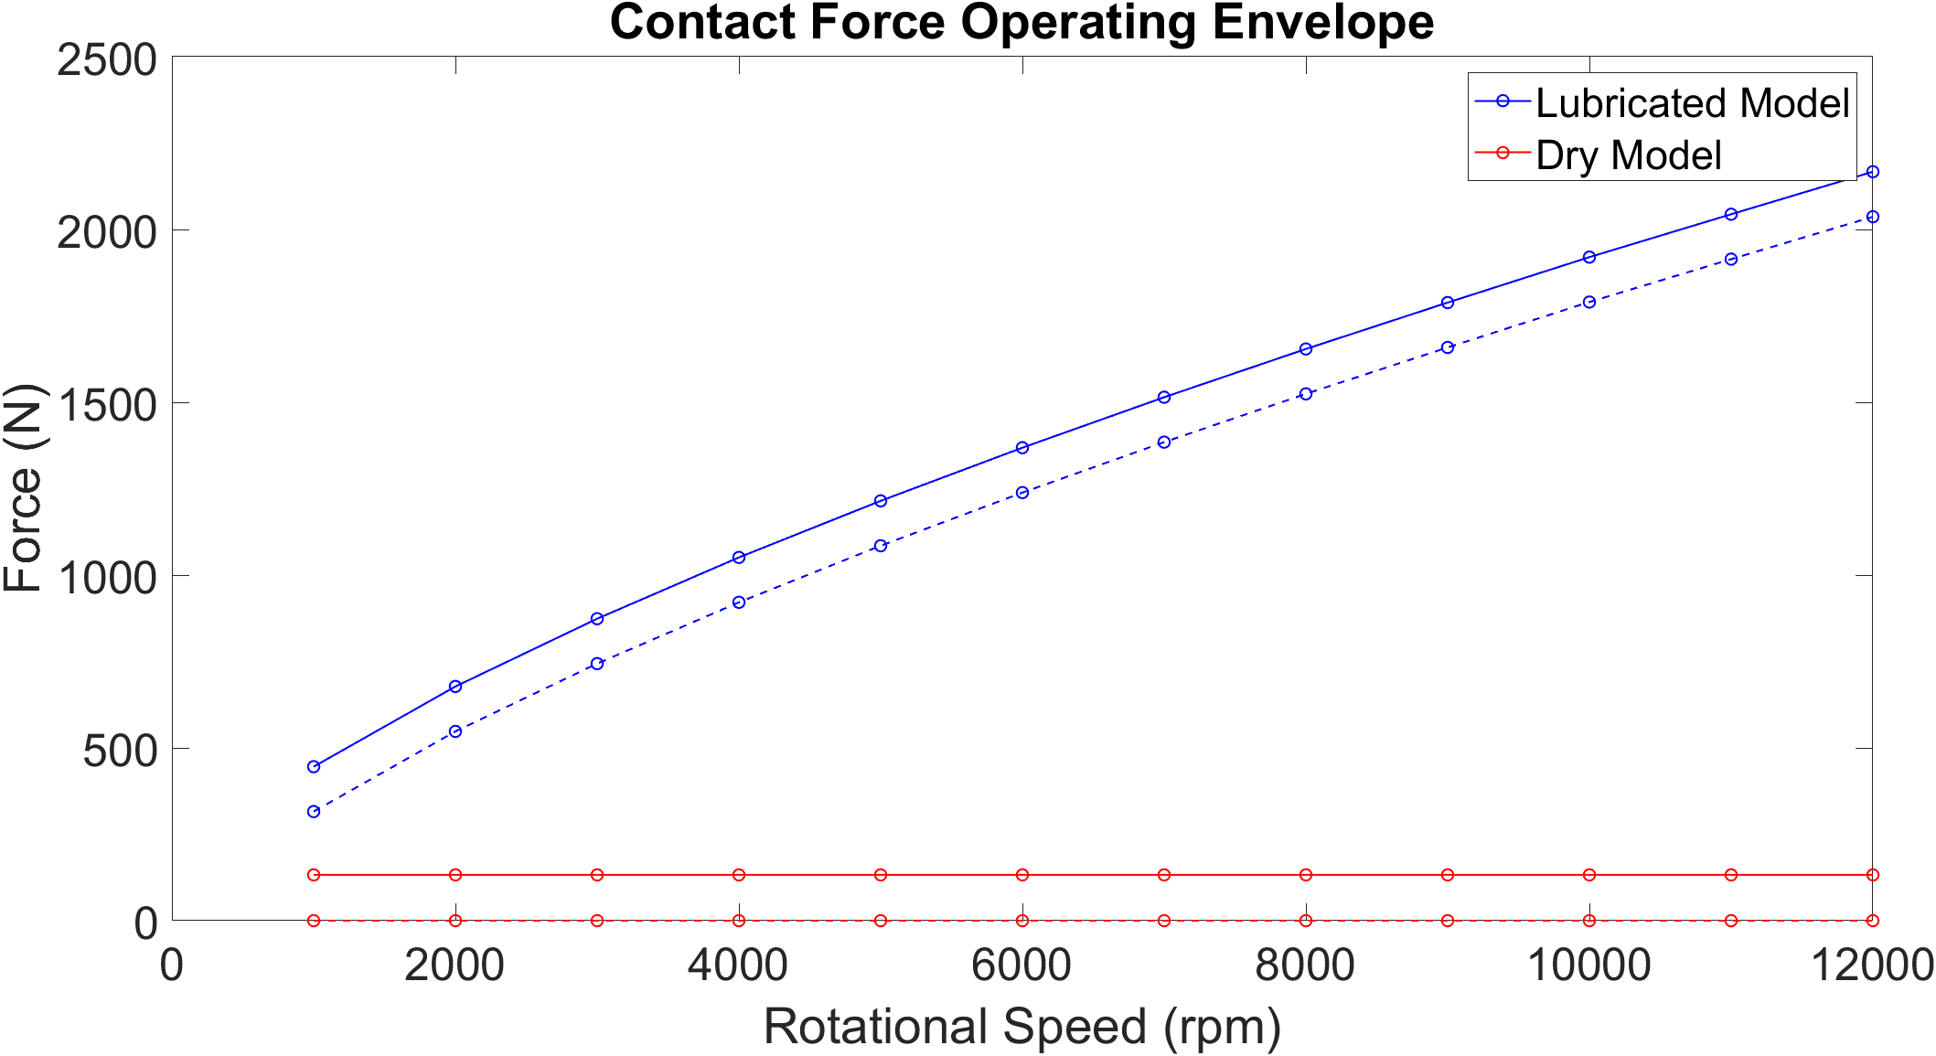

Figure 15 - Contact Force Operating Envelope

Contact force follows the same behaviour of as the contact deformation due to the force-deflection relationship. The 0 N values in the dry model indicated roller-race separation at all speeds.

### Contact Stiffness

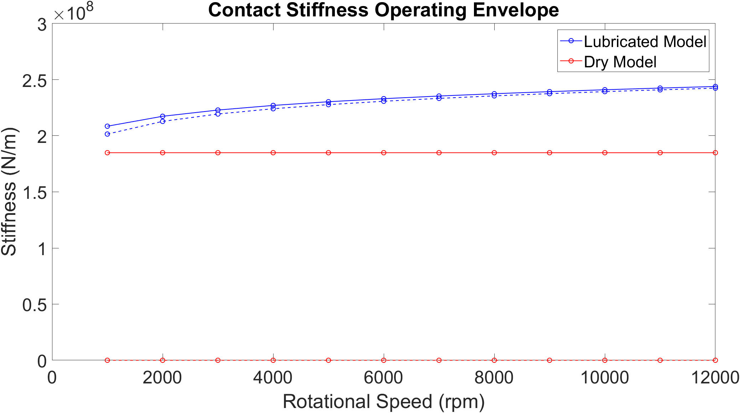

Figure 16 - Contact Stiffness Operating Envelope

Contact stiffness increases with contact deformation in the lubricated model due to increased contact deformation and the non-linear force relationship of the contact. Much greater peak to peak fluctuations occur for the dry model due to the convergence and separation of the races resulting in an unloaded region and hence zero contact stiffness when the roller reach the 12 o’clock position of the bearing.

### Total Bearing Stiffness

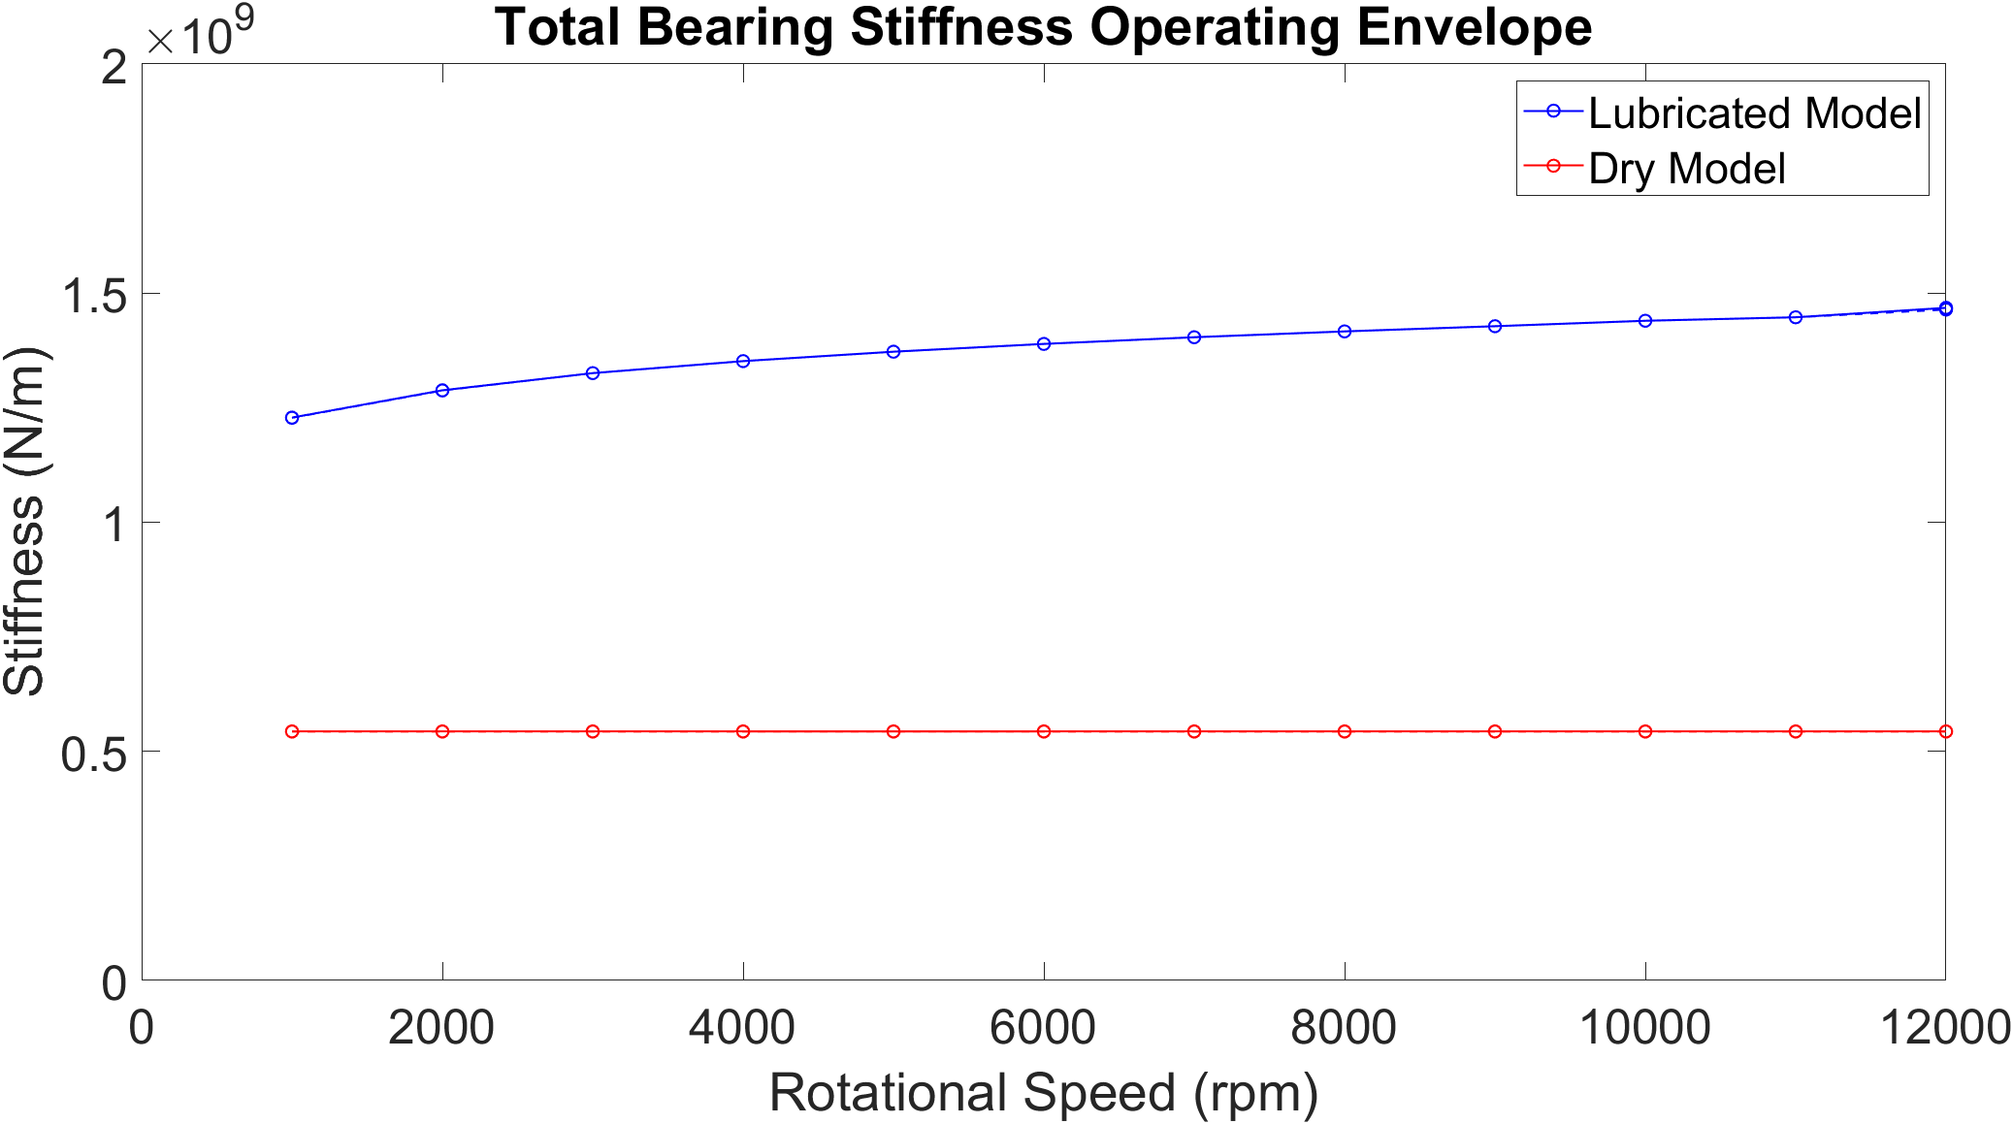

Figure 17 - Total Bearing Stiffness Operating Envelope

The total bearing stiffness results from all contact stiffnesses between rollers and raceways acting in parallel. The total stiffness for the dry cases remains constant at 0.58 x 109 N/m. This is expected as the contact stiffness does not vary with speed as shown in Figure 16. For the lubricated model, due to the increase in each contact stiffness for each roller, the total bearing stiffness increases with speed. This is the reason why for a given force on the inner race, the displacement of the inner race reduces with speed as shown in Figure 12.

## Greenwood Regimes of Lubrication

For the case of the lubricated bearing with no clearance, contact deformation occurs between each roller and race around its entire orbit due to the presence of the lubricant film. Under these conditions, the lubricant regime is elastohydrodynamic for the full cycle. If the bearing has clearance and force magnitudes are large enough to cause separation of the raceways, then the regime of lubrication will transition from EHL to hydrodynamic.

A method of modelling the regime of lubrication that the contact is operating under is using Greenwood regimes of elastohydrodynamic lubrication. The charts display the physical effects instrumental to EHL formation under isothermal conditions: viscosity rise due to pressure and elastic deformation of the surface.

The piezoviscous elastic (PE) regime signifies the EHL regime of lubrication where contact pressures are such that elastic deformation of the surfaces and viscosity rise due to pressure increase is significant. The iso-viscous rigid (IR) regime occurs when the magnitude of elastic deformation is insignificant, and the contact pressures are low enough that viscosity rise is negligible, i.e. hydrodynamic lubrication.

Contact force per unit length and entrainment velocity for roller loading cycles at 4 000 rpm, 8 000 rpm ad 12 000 rpm were used to calculate the viscosity parameter, A, and elasticity parameter, B. The results are then overlayed on the line contact boundaries to assess how far into each region the contact operates. It is shown that as speed increases, due the greater value of contact deflection and hence force, the greater pressures result in the contact moving further into the piezoviscous elastic region of the plot.

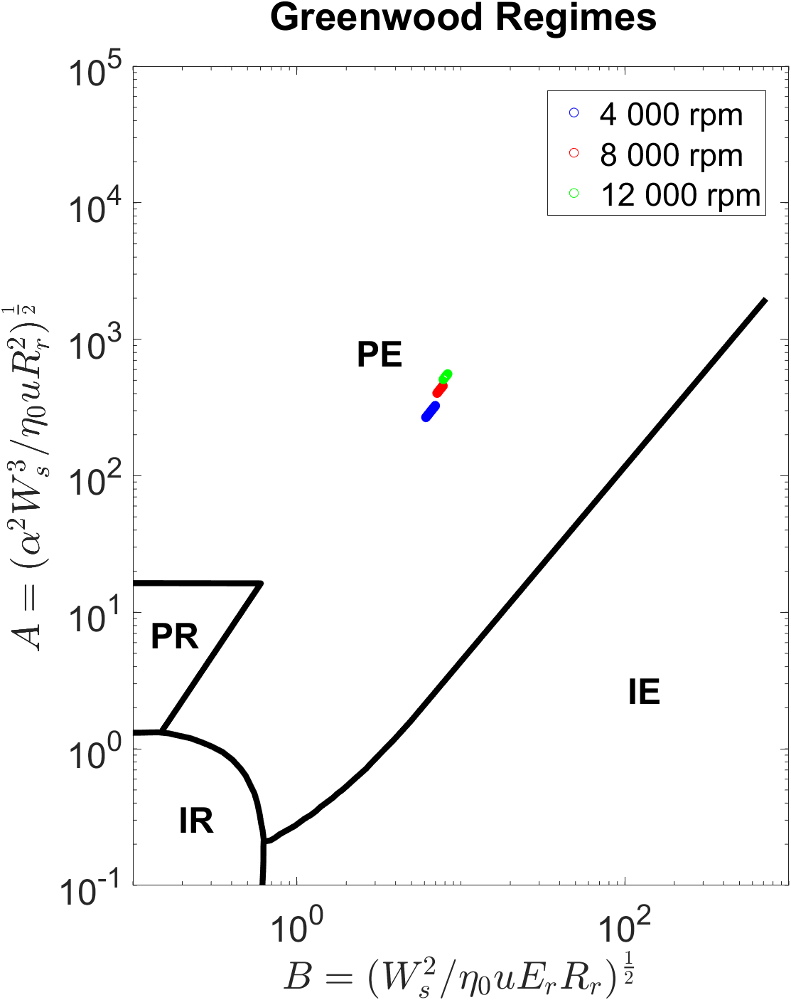

Figure 18 - Greenwood Regimes for Contact Conditions at 4 000, 8 000 and 12 000 rpm

# Conclusion

This work has introduced the methodology of coupling a non-linear lubricated bearing model with a flexible system level model. To the author’s knowledge, high speed analysis of a flexible system level model containing lubricated bearings has not been performed. The methodology used here can be developed to integrate lubricated bearings within more complex systems, such as full electrified powertrain models.

Results show that film thickness increases with rotational speed of the shaft due to the higher contact entrainment velocities. The rigid film adds to the total contact deformation predicted by the dry-Hertzian assumption, and as a result, the reaction force at the contact increases. Between 4 000 – 12 000 rpm in the lubricated mode, the EHL film in the contact grows by 2.1 µm, resulting in a doubling of the contact loads between rollers and races. At 12 000 rpm, the contact load magnitude difference between the dry and lubricated model is 16 times. Stiffness of the contact also increases with speed due to the higher contact deflections and non-linear force-deflection relationship. This means that under simply loaded conditions, the total stiffness of the bearing increases by 2.5 times due to the contribution of all roller-raceways stiffnesses. In a full system level model, this will significantly impact the NVH response which need to be accurately characterized. The contact load differences will also affect durability and wear within the bearing contacts, with higher contact pressures resulting in greater sub-surface stresses.

For this simple shaft model, the full effect of shaft flexibility was not observed. The excitation energies resulting from the contact loads were not great enough to excite resonant frequencies within the shaft. With time-varying input forces, higher loads and more flexible structures within the model, the frequency response of the system can be analysed in greater detail to see how the change in bearing stiffness affects full system dynamics.

The workflow can be extended to include 1D numerical EHL analysis of the contacts at each time step of a load cycle, as presented in Chapter 2. The pressure, film and viscosity distributions can be used to calculate contact friction and sub-surface stresses to extend the analysis further and model wear.

# Additional Work for Chapter

**Time-varying force input on shaft**

The current system level model uses a static radial load on the shaft. Excitation fluctuations resulting from the rollers entering and exiting the loaded regions were very low magnitude, resulting in low total bearing forces acting on the shaft. Resonant frequencies of the shaft were therefore not observed through the speed sweep. This model will be extended to include time-varying input forces on the shaft to capture these resonances and better observe the NVH phenomena occurring as a result of using lubricated bearings.

**Investigate the influence of varying clearance and preload in the bearing**

There is a large contact force magnitude difference between the dry and lubricated models due to the zero-clearance condition of the bearing. Preload, or negative clearance, would load the rollers around the entire orbit and result in a higher constant stiffness of the dry bearing. Clearance may also result in a higher prevalence of unloaded regions of the bearing for both dry and lubricated cases.

**Higher shaft rotational speeds**

The models in this study have been run up to 12 000 rpm. Simulations are currently being run to extend this up to 20 000 rpm.

**Varying damping coefficient**

The damping coefficient of the bearings in these studies was kept at zero for initial studies. The value of this damping will be varied to observe its effect on the system and bring it closer to experimental findings of contact and total bearing damping.

**Experimental validation using high-speed roller bearing test rig**

The current test rig has been replicated at system level within the flexible multi-body software. Some modifications need to be performed on the rig to use it as system level validation for this work. The shaft and brackets can be instrumented to measure race displacement and observe this effect at different speeds for lubricated and dry bearings.

Nomenclature

|  |  |
| --- | --- |
|  | Viscosity parameter (-) |
| B | Elasticity parameter (-) |
|  | Half-length of the contact (mm) |
| C | Radial clearance (µm) |
|  | Diameter of roller (mm) |
|  | Damping coefficient of flexible body (N.s.m-1) |
|  | 3 x 3 unit matrix (-) |
|  | Equivalent (reduced) elastic modulus (Pa) |
|  | Radial load in z-direction (N) |
|  | Sub vector of forces (N) |
|  | Vector of external loads (N) |
|  | Vector of joint forces (N) |
|  | Joint forces in z-direction (N) |
|  | Joint forces in y-direction (N) |
|  | Internal forces and moments vector of node (-) |
|  | Internal forces and moments vector of node (-) |
|  | Force vector applied to node given in absolute coordinates (N) |
|  | Moment vector applied to node given in absolute coordinates (Nm) |
|  | Damping factor (-) |
|  | Dimensionless equivalent geometry (-) |
|  | Central film thickness (m) |
|  | Mass moment of inertia of node (kg.m2) |
|  | Flexible body stiffness (Nm-1) |
| K | Contact stiffness (Nm-1) |
|  | Active length of roller slice (mm) |
|  | Roller length (mm) |
|  | Mass tensor (kg) |
|  | Mass matrix of body (kg) |
|  | Exponent of localized deflection (-) |
| N | Number of rolling elements (-) |
|  | Contact pressure (Pa) |
|  | Vector of nonlinear inertia forces and moments (-) |
|  | Vector of generalized displacements (m) |
|  | Vector of generalized velocities (m.s-1) |
|  | Vector of generalized accelerations (m.s-2) |
|  | Radius of inner race (mm) |
|  | Equivalent radius of contact (mm) |
|  | Speed of entraining motion (m.s-1) |
|  | Vector of local translations (m) |
|  | Dimensionless speed parameter (-) |
|  | Velocity (m.s-1) |
|  | Contact load (N) |
|  | Contact load per unit length (N.m-1) |
|  | Contact load per unit length of roller slice, (N.m-1) |
|  | Dimensionless load parameter (-) |
|  | Asperity load (N) |
|  | Load per unit length (N.m-1) |
|  | Vector of global position of node relative to the centre of gravity |
|  | Displacement in z-direction (m) |
|  | Conjunction z-coordinate (-) |
|  | Displacement in y-direction (m) |
|  | Conjunction y-coordinate (-) |

**Greek Symbols:**

|  |  |
| --- | --- |
|  | Angular position (rad) |
|  | Vector of local rotations (rad) |
|  | Pressure viscosity coefficient (m2.N-1) |
|  | Contact deflection (m) |
|  | Contact deflection of roller slice, (m) |
|  | Atmospheric lubricant dynamic viscosity (Pa.s) |
|  | Lubricant dynamic viscosity (Pa.s) |
|  | Lubricant density (kg.m-3) |
|  | Atmospheric lubricant density (kg.m-3) |
|  | Vector of angular velocities of node relative to the centre of gravity |
|  | Angular velocity of cage (rad.s-1) |
|  | Angular velocity of inner race (rad.s-1) |

[1] H. Questa, M. Mohammadpour, S. Theodossiades, C. P. Garner, S. R. Bewsher, and G. Offner, “Tribo-dynamic analysis of high-speed roller bearings for electrified vehicle powertrains,” *Tribol. Int.*, vol. 154, 2021, doi: 10.1016/j.triboint.2020.106675.

[2] J. M. de Mull, J. M. Vree, and D. A. Maas, “Equilibrium and associated load distribution in ball and roller bearings loaded in five degrees of freedom while neglecting friction - part II: application to roller bearings and experimental verification.,” vol. 111, 1988.

[3] D. W. Dareing and K. L. Johnson, “Fluid Film Damping of Rolling Contact Vibrations,” *J. Mech. Eng. Sci.*, vol. 17, no. 4, pp. 214–218, Aug. 1975, doi: 10.1243/JMES_JOUR_1975_017_031_02.

[4] H. Mehdigoli, H. Rahnejat, and R. Gohar, “Vibration response of wavy surfaced disc in elastohydrodynamic rolling contact,” *Wear*, vol. 139, no. 1, pp. 1–15, 1990, doi: 10.1016/0043-1648(90)90206-P.

[5] M. Mohammadpour, P. Johns-Rahnejat, and H. Rahnejat, “Roller bearing dynamics under transient thermal-mixed non-Newtonian elastohydrodynamic regime of lubrication,” *Proc. Inst. Mech. Eng. Part K J. Multi-body Dyn.*, vol. 229, no. 4, pp. 407–423, Dec. 2015, doi: 10.1177/1464419315569621.

[6] K. P. Singh and B. Paul, “Numerical Solution of Non-Hertzian Elastic Contact Problems,” *J. Appl. Mech.*, vol. 41, no. 2, pp. 484–490, Jun. 1974, doi: 10.1115/1.3423314.

[7] H. Hertz, “On the Contact of Elastic Solids,” *J. Reine Angew, Math.*, vol. 92, pp. 156–171, 1881.

[8] T. A. Harris and M. N. Kotzales, *Advanced Concepts of Bearing Technology*, Fifth. Boca Raton, FL: Taylor and Francis Group, 2007.

[9] S. Andréason, “Load distribution in a taper roller bearing arrangement considering misalignment,” *Tribology*, vol. 6, no. 3, pp. 84–92, Jun. 1973, doi: 10.1016/0041-2678(73)90241-8.

[10] G. Lundberg and E. Yhland, “Cylinder compressed between two plane bodies,” *SKF*, 1949.

[11] J. M. de Mul, J. J. Kalker, and B. Fredriksson, “The contact between arbitrarily curved bodies of finite dimensions,” *J. Tribol.*, vol. 108, no. 1, pp. 140–148, 1986, doi: 10.1115/1.3261134.

[12] P. Dietl, J. Wensing, and G. C. Van Nijen, “Rolling bearing damping for dynamic analysis of multi-body systems - Experimental and theoretical results,” *Proc. Inst. Mech. Eng. Part K J. Multi-body Dyn.*, vol. 214, no. 1, pp. 33–43, 2000, doi: 10.1243/1464419001544124.

[13] E. Krämer, *Dynamics of Rotors and Foundations*. Berlin, Heidelberg: Springer Berlin Heidelberg, 1993.

[14] H. Rahnejat, “Influence of vibration on the oil film in concentrated contacts,” University of London, 1984.

[15] D. Dowson and S. Toyoda, “A Central Film Thickness Formula for Elastohydrodynamic Line,” *Proc. Fifth Leeds-Lyon Symp. Tribol. Mech. Eng. Publ.*, pp. 60–65, 1979.